C-ATS tool Examination (L1)

Q1. Which action is the correct if you need auto scroll page and click an item on a list? (Single Choice) [ ]

1. Click
2. UIAClick
3. TSClick
4. UIAClickListItem

Q2. Which is the correct predefined variable for DUT? (Single Choice) [ ]

1. ${resources}
2. ${caseFolder}
3. ${deviceId0}
4. ${deviceId2}

Q3. When you need verify a text (highlight by red rectangle) in following screen, which action is the best recommended choice? (Single Choice) [ ]

1. Verify
2. UIAVerify
3. VerifyFSATcp
4. VerifyListItem

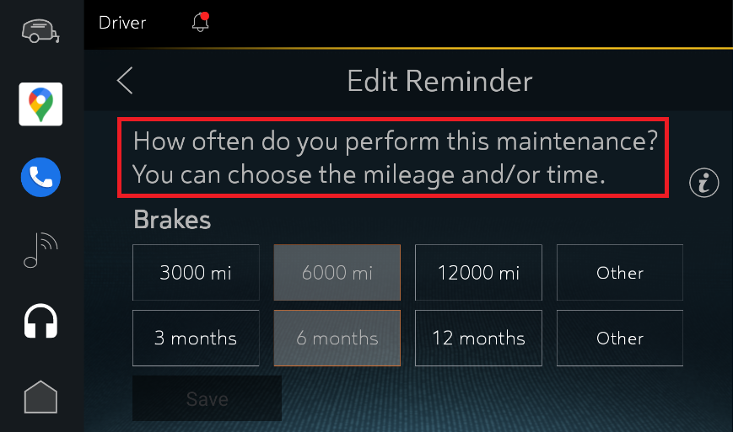

Q4. If you need verify an UI object which would be display in a short but uncertain time, which of following action is fit for this situation? (Single Choice) [ ]

1. ImageCompare
2. ImageCompareConstantly
3. Verify
4. UIAVerify

Q5. Which of following action can send CAN signal? (Single Choice) [ ]

1. SendCANMessage
2. SendCANMessage2
3. SendLINMessage
4. GetCANMessage2

Q6. If you want to print the comment to testing report, which is the best action for it? (Single Choice) [ ]

1. Delay
2. Comments
3. InputText
4. Monkey

Q7. ConnectRequest action lets the device make connection operation. Which of the following feature can use this action? (Multiple choices) [ ]

1. Bluetooth
2. WIFI
3. Audio
4. Android Auto

Q8. When you need execute a local executable third party program in C-ATS action, which action you can use? (Multiple choices) [ ]

1. ExecCommand
2. ExecLocalCommand
3. ExtFunction
4. PushFile

Q9. Which of the following action need an action to stop it? (Multiple choices) [ ]

1. SendPerdCANMSG
2. SendPerdLINMSG
3. StartRecAudio
4. SwipePage

Q10. Which of the following action can do action on iPhone? (Multiple choices) [ ]

1. IOSSingleScreenshot
2. TSClick
3. TSLongClick
4. IOSVerify